Lab Taks-6
Submission Guidelines-
- Rename the file with your serial number only
- Must submit within the time discussed in class
- Must include resources for all the section in the table
Question-
Develop an animation that will change the background color of the window after 20ms. Use at least two different colors.

Graph-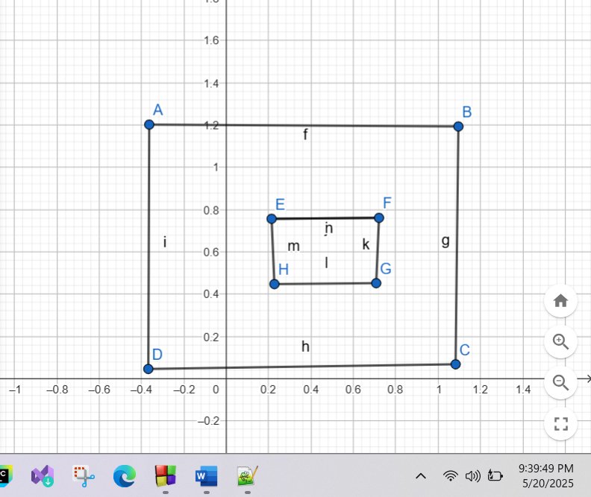

Code-

#include <windows.h>
#include <GL/glut.h>

// Define color states (R, G, B)
float bgColors[][3] = {
{0.2f, 0.3f, 0.8f}, // Blueish
{0.9f, 0.6f, 0.1f}, // Orange
{0.2f, 0.6f, 0.2f}, // Greenish
{0.6f, 0.2f, 0.5f} // Purple
};

int colorIndex = 0;
int totalColors = sizeof(bgColors) / sizeof(bgColors[0]);

void display() {
// Clear screen with current background color
glClear(GL_COLOR_BUFFER_BIT);

// Optional: draw something to make it obvious
glColor3f(1.0, 1.0, 1.0);
glBegin(GL_QUADS);
glVertex2f(-0.2f, -0.2f);
glVertex2f(0.2f, -0.2f);
glVertex2f(0.2f, 0.2f);
glVertex2f(-0.2f, 0.2f);
glEnd();

glFlush();
}

void changeBackgroundColor(int value) {
// Update background color
float* color = bgColors[colorIndex];
glClearColor(color[0], color[1], color[2], 1.0f);

// Move to next color
colorIndex = (colorIndex + 1) % totalColors;

glutPostRedisplay();
glutTimerFunc(20, changeBackgroundColor, 0);
}

void init() {
glClearColor(bgColors[0][0], bgColors[0][1], bgColors[0][2], 1.0f); // Initial color
glMatrixMode(GL_PROJECTION);
glLoadIdentity();
gluOrtho2D(-1, 1, -1, 1);
}

int main(int argc, char** argv) {
glutInit(&argc, argv);
glutInitDisplayMode(GLUT_SINGLE | GLUT_RGB); // Needed for proper rendering
glutInitWindowSize(800, 600);
glutInitWindowPosition(100, 100);
glutCreateWindow("Background Color Animation");
init();
glutDisplayFunc(display);
glutTimerFunc(20, changeBackgroundColor, 0);
glutMainLoop();
return 0;
}

Output Screenshot (Full Screen)-
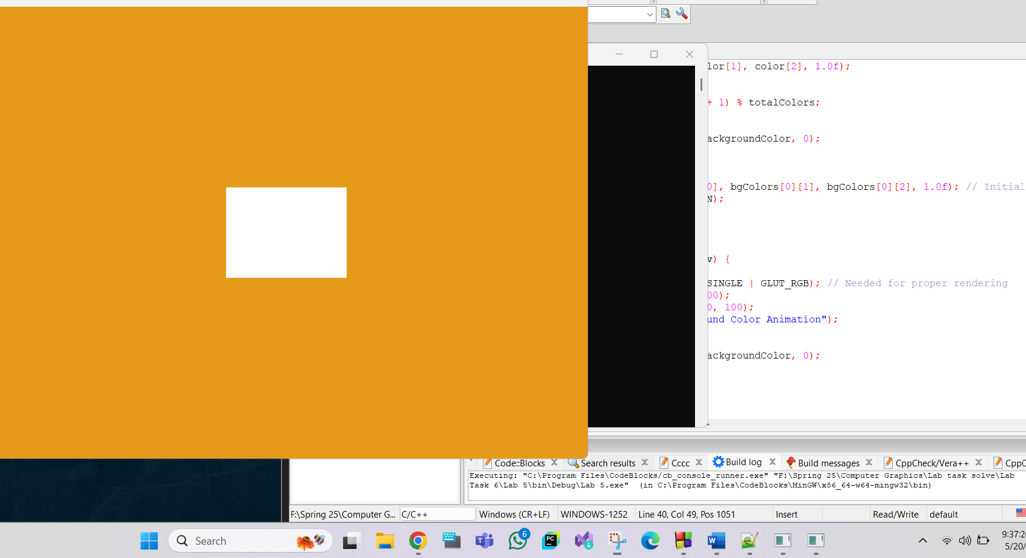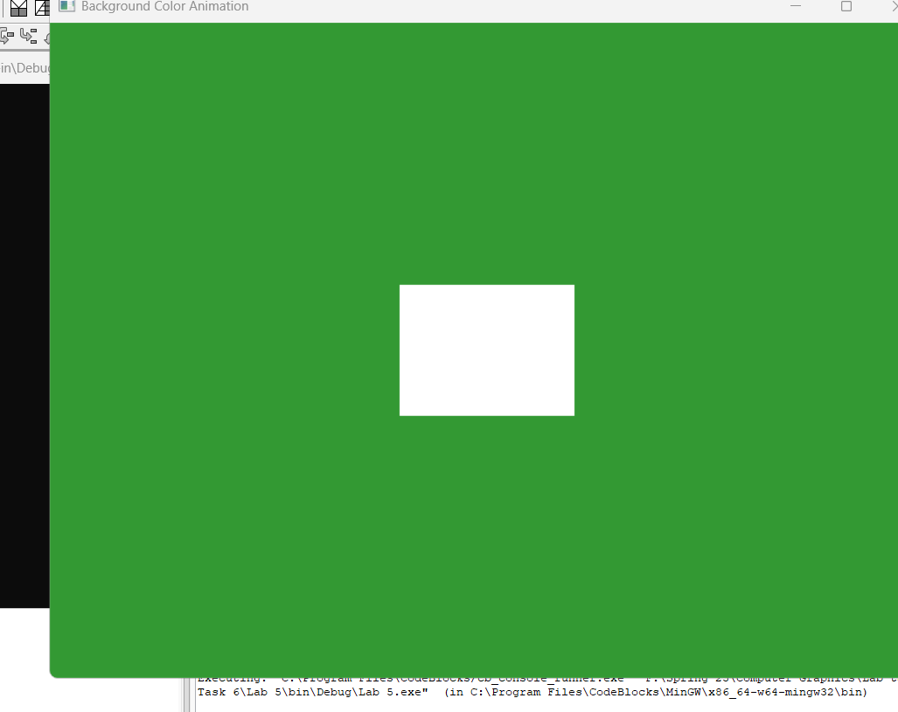

Question-
Develop an animation that will call four objects separately, each after 20 ms.

Graph-
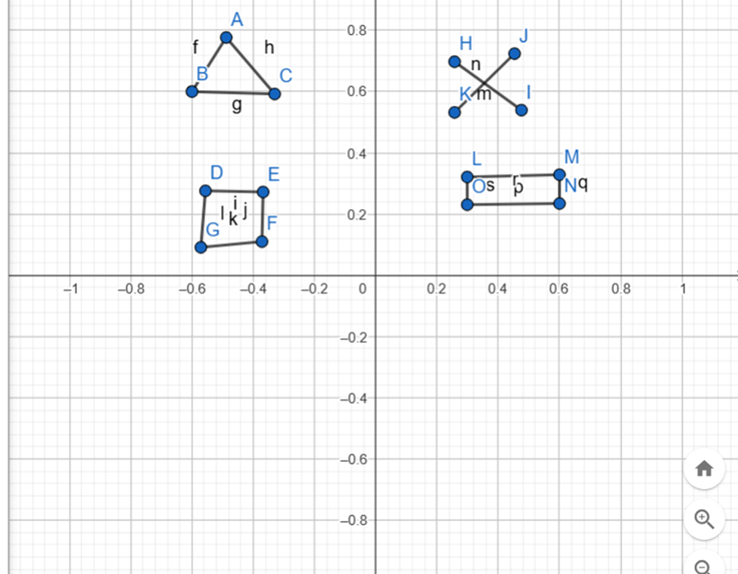
Code-
#include <windows.h>
#include <GL/glut.h>

struct Object {
float x, y;
float dx, dy;
int type; // 0: rectangle, 1: triangle, 2: star, 3: diamond
};

Object objects[4] = {
{-0.8f, 0.6f, 0.01f, 0.0f, 0}, // Rectangle → right
{ 0.8f, 0.4f, -0.01f, 0.0f, 1}, // Triangle ← left
{-0.4f, -0.8f, 0.0f, 0.01f, 2}, // Star ↑ up
{ 0.4f, 0.8f, 0.0f, -0.01f, 3} // Diamond ↓ down
};

void drawRectangle(float x, float y) {
glBegin(GL_QUADS);
glVertex2f(x - 0.05f, y - 0.03f);
glVertex2f(x + 0.05f, y - 0.03f);
glVertex2f(x + 0.05f, y + 0.03f);
glVertex2f(x - 0.05f, y + 0.03f);
glEnd();
}

void drawTriangle(float x, float y) {
glBegin(GL_TRIANGLES);
glVertex2f(x, y + 0.05f);
glVertex2f(x - 0.05f, y - 0.05f);
glVertex2f(x + 0.05f, y - 0.05f);
glEnd();
}

void drawStar(float x, float y) {
glBegin(GL_LINES);
glVertex2f(x - 0.05f, y - 0.05f);
glVertex2f(x + 0.05f, y + 0.05f);

glVertex2f(x + 0.05f, y - 0.05f);
glVertex2f(x - 0.05f, y + 0.05f);
glEnd();
}

void drawDiamond(float x, float y) {
glBegin(GL_POLYGON);
glVertex2f(x, y + 0.05f);
glVertex2f(x + 0.04f, y);
glVertex2f(x, y - 0.05f);
glVertex2f(x - 0.04f, y);
glEnd();
}

void drawObject(Object& obj) {
switch (obj.type) {
case 0:
glColor3f(0.2f, 0.6f, 1.0f); // Blue
drawRectangle(obj.x, obj.y);
break;
case 1:
glColor3f(1.0f, 0.4f, 0.2f); // Orange
drawTriangle(obj.x, obj.y);
break;
case 2:
glColor3f(0.8f, 1.0f, 0.1f); // Yellow-green
drawStar(obj.x, obj.y);
break;
case 3:
glColor3f(0.7f, 0.2f, 1.0f); // Purple
drawDiamond(obj.x, obj.y);
break;
}
}

void update(int value) {
for (int i = 0; i < 4; ++i) {
objects[i].x += objects[i].dx;
objects[i].y += objects[i].dy;

// Wrap-around
if (objects[i].x > 1.1f) objects[i].x = -1.1f;
if (objects[i].x < -1.1f) objects[i].x = 1.1f;
if (objects[i].y > 1.1f) objects[i].y = -1.1f;
if (objects[i].y < -1.1f) objects[i].y = 1.1f;
}

glutPostRedisplay();
glutTimerFunc(16, update, 0); // ~60 FPS
}

void display() {
glClear(GL_COLOR_BUFFER_BIT);

for (int i = 0; i < 4; ++i) {
drawObject(objects[i]);
}

glFlush();
}

void init() {
glClearColor(0.1f, 0.1f, 0.1f, 1.0f); // Dark background
glMatrixMode(GL_PROJECTION);
glLoadIdentity();
gluOrtho2D(-1, 1, -1, 1);
}

int main(int argc, char** argv) {
glutInit(&argc, argv);
glutInitWindowSize(800, 600);
glutCreateWindow("Four Different Objects Moving");
init();
glutDisplayFunc(display);
glutTimerFunc(0, update, 0);
glutMainLoop();
return 0;
}

Output Screenshot (Full Screen)-

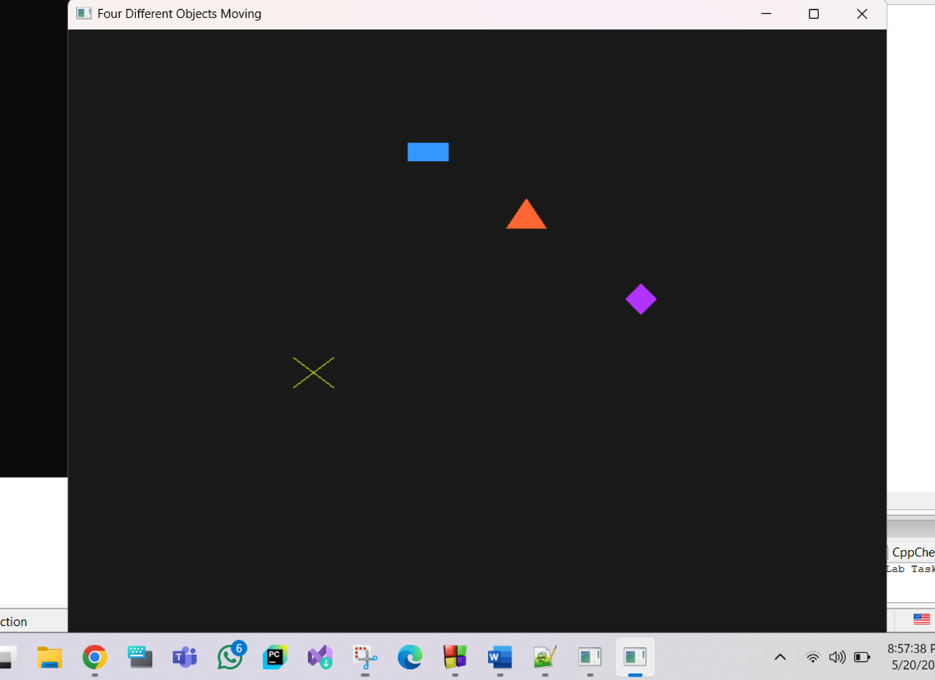

Question-
Develop a code that will have four different objects (keep it simple). The objects will move to the left, right, up and down in a loop.

Graph-
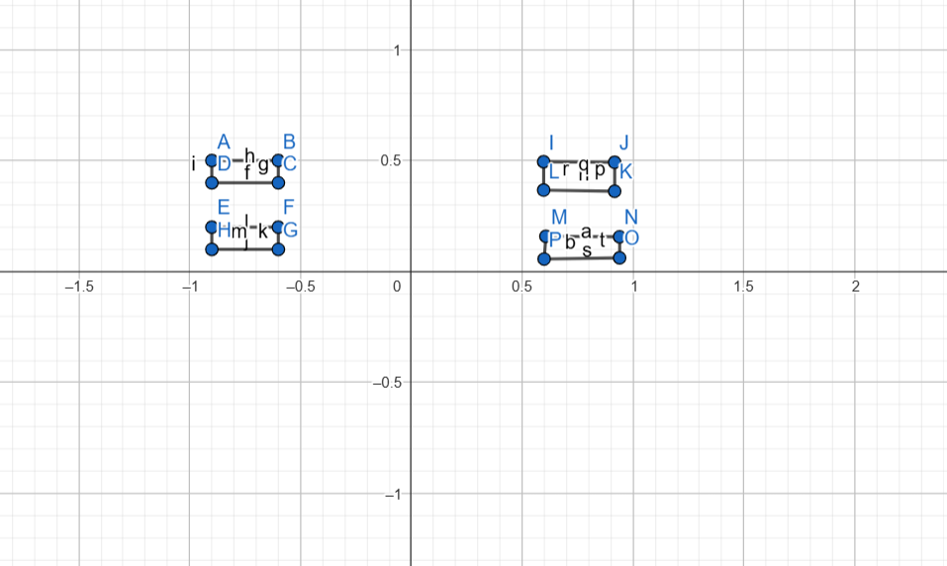
Code-
#include <windows.h>
#include <GL/glut.h>

// Visibility flags for each object
bool show[4] = {false, false, false, false};

// Draw a rectangle at a position with color
void drawRectangle(float x, float y, float r, float g, float b) {
glColor3f(r, g, b);
glBegin(GL_QUADS);
glVertex2f(x - 0.1f, y - 0.05f);
glVertex2f(x + 0.1f, y - 0.05f);
glVertex2f(x + 0.1f, y + 0.05f);
glVertex2f(x - 0.1f, y + 0.05f);
glEnd();
}

// Display function to render all visible objects
void display() {
glClear(GL_COLOR_BUFFER_BIT);

if (show[0]) drawRectangle(-0.7f, 0.6f, 1.0f, 0.0f, 0.0f); // Red
if (show[1]) drawRectangle( 0.7f, 0.6f, 0.0f, 1.0f, 0.0f); // Green
if (show[2]) drawRectangle(-0.7f, -0.6f, 0.0f, 0.0f, 1.0f); // Blue
if (show[3]) drawRectangle( 0.7f, -0.6f, 1.0f, 1.0f, 0.0f); // Yellow

glFlush();
}

// Timer callback to enable object i and set next one
void revealObject(int i) {
if (i < 4) {
show[i] = true;
glutPostRedisplay();
glutTimerFunc(20, revealObject, i + 1);
}
}

void init() {
glClearColor(0.1f, 0.1f, 0.1f, 1.0f); // Dark background
glMatrixMode(GL_PROJECTION);
glLoadIdentity();
gluOrtho2D(-1.0, 1.0, -1.0, 1.0);
}

int main(int argc, char** argv) {
glutInit(&argc, argv);
glutInitWindowSize(800, 600);
glutCreateWindow("Sequential Rectangle Animation");
init();
glutDisplayFunc(display);
glutTimerFunc(20, revealObject, 0); // Start revealing rectangles
glutMainLoop();
return 0;
}
Output Screenshot (Full Screen)-
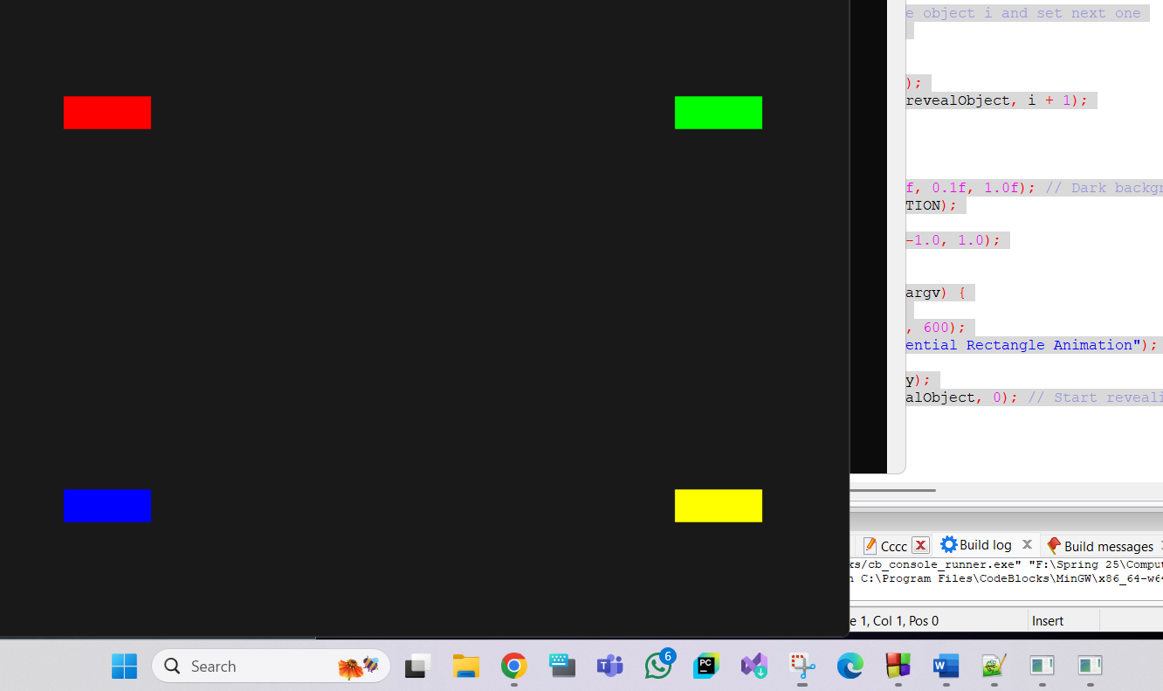

Question-
Develop a code that will have four different objects (keep it simple). Four different keys will be dedicated each objects. The objects will move to the left, right, up and down in a loop as the keys are pressed individually.

Graph-
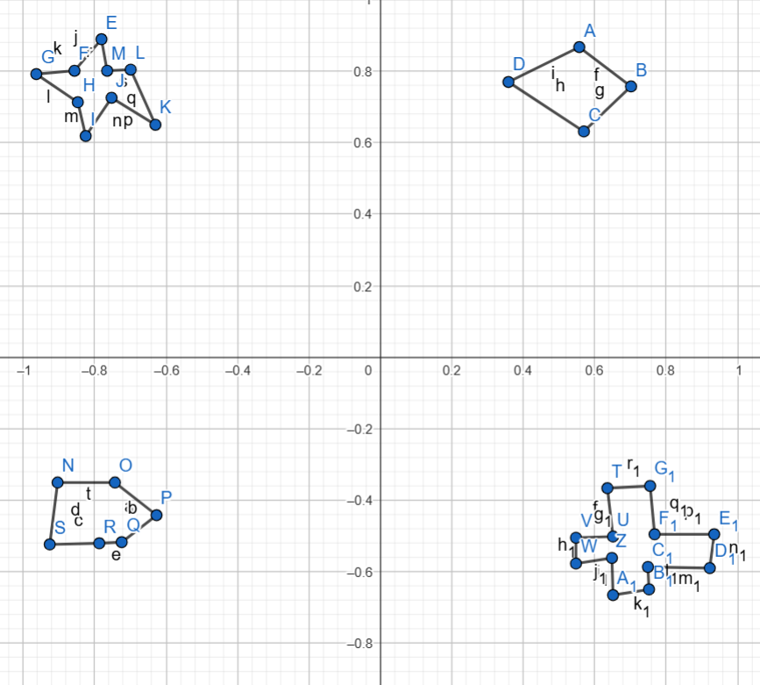
Code-
#include <windows.h>
#include <GL/glut.h>
#include <cmath>

float starX = -0.6f, starY = 0.6f;
float diamondX = 0.6f, diamondY = 0.6f;
float pentagonX = -0.6f, pentagonY = -0.6f;
float crossX = 0.6f, crossY = -0.6f;

float moveSpeed = 0.025f;

void drawStar(float x, float y) {
glColor3f(0.6f, 0.1f, 0.7f); // Purple
float radius = 0.05f;
glBegin(GL_TRIANGLE_FAN);
glVertex2f(x, y);
for (int i = 0; i <= 10; i++) {
float angle = i * 3.14159f / 5.0f;
float r = (i % 2 == 0) ? radius : radius / 2;
glVertex2f(x + cos(angle) * r, y + sin(angle) * r);
}
glEnd();
}

void drawDiamond(float x, float y) {
glColor3f(1.0f, 0.5f, 0.0f); // Orange
glBegin(GL_QUADS);
glVertex2f(x, y + 0.06f);
glVertex2f(x + 0.06f, y);
glVertex2f(x, y - 0.06f);
glVertex2f(x - 0.06f, y);
glEnd();
}

void drawPentagon(float x, float y) {
glColor3f(0.2f, 0.8f, 0.2f); // Green
glBegin(GL_POLYGON);
for (int i = 0; i < 5; i++) {
float angle = i * 2.0f * 3.14159f / 5.0f;
glVertex2f(x + cos(angle) * 0.05f, y + sin(angle) * 0.05f);
}
glEnd();
}

void drawCross(float x, float y) {
glColor3f(0.9f, 0.1f, 0.1f); // Red
float size = 0.02f;
glBegin(GL_QUADS);
glVertex2f(x - size, y + 3 * size);
glVertex2f(x + size, y + 3 * size);
glVertex2f(x + size, y - 3 * size);
glVertex2f(x - size, y - 3 * size);

glVertex2f(x - 3 * size, y + size);
glVertex2f(x + 3 * size, y + size);
glVertex2f(x + 3 * size, y - size);
glVertex2f(x - 3 * size, y - size);
glEnd();
}

void display() {
glClear(GL_COLOR_BUFFER_BIT);
drawStar(starX, starY);
drawDiamond(diamondX, diamondY);
drawPentagon(pentagonX, pentagonY);
drawCross(crossX, crossY);
glFlush();
}

void keyboard(unsigned char key, int x, int y) {
switch (key) {
// Star (WASD)
case 'w': starY += moveSpeed; break;
case 's': starY -= moveSpeed; break;
case 'a': starX -= moveSpeed; break;
case 'd': starX += moveSpeed; break;

// Diamond (IJKL)
case 'i': diamondY += moveSpeed; break;
case 'k': diamondY -= moveSpeed; break;
case 'j': diamondX -= moveSpeed; break;
case 'l': diamondX += moveSpeed; break;

// Pentagon (TFGH)
case 't': pentagonY += moveSpeed; break;
case 'g': pentagonY -= moveSpeed; break;
case 'f': pentagonX -= moveSpeed; break;
case 'h': pentagonX += moveSpeed; break;

// Cross (UYMO)
case 'u': crossY += moveSpeed; break;
case 'm': crossY -= moveSpeed; break;
case 'y': crossX -= moveSpeed; break;
case 'o': crossX += moveSpeed; break;
}

glutPostRedisplay();
}

void init() {
glClearColor(0.1f, 0.1f, 0.15f, 1.0f); // Dark background
glMatrixMode(GL_PROJECTION);
glLoadIdentity();
gluOrtho2D(-1, 1, -1, 1);
}

int main(int argc, char** argv) {
glutInit(&argc, argv);
glutInitWindowSize(800, 600);
glutCreateWindow("Move 4 Unique Objects");
init();
glutDisplayFunc(display);
glutKeyboardFunc(keyboard);
glutMainLoop();
return 0;
}

Output Screenshot (Full Screen)- 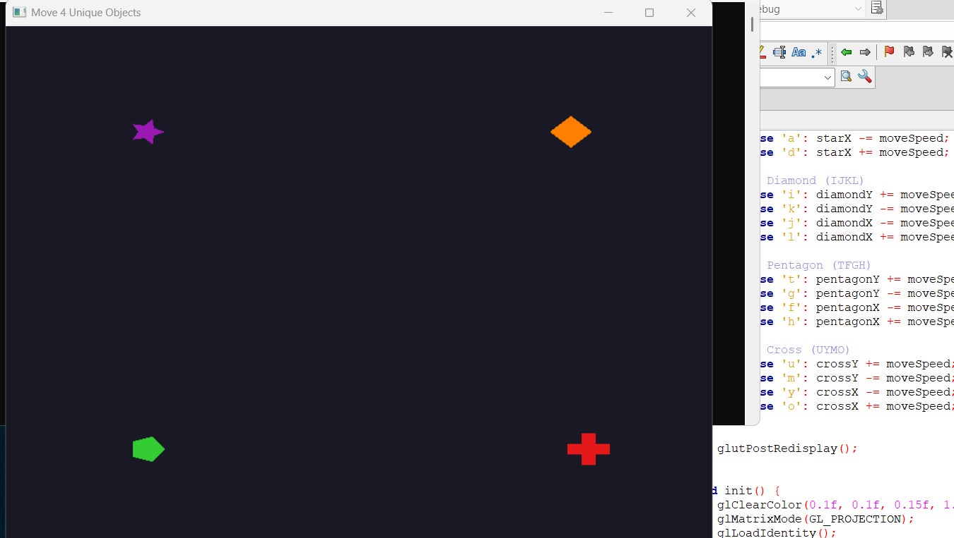

Question-
Develop a scenario where it will rain and gradually create flood

Graph- 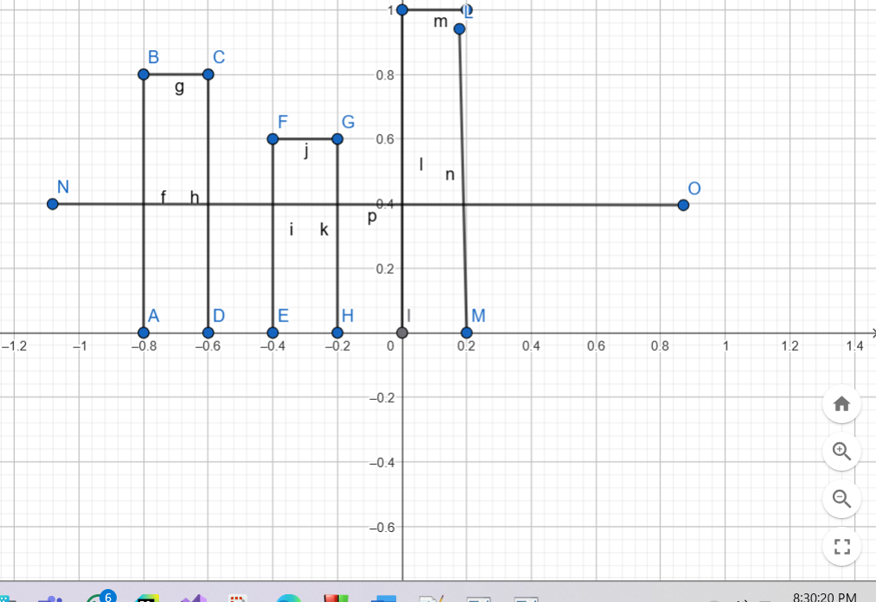

Code- #include <windows.h>
#include <GL/glut.h>
#include <stdlib.h>

#define MAX_DROPS 800

float dropX[MAX_DROPS];
float dropY[MAX_DROPS];
int totalDrops = 0;

float lakeLevel = -0.6f;
float roadFloodLevel = -0.3f;
bool isFlooding = false;

void addDrop() {
if (totalDrops < MAX_DROPS) {
dropX[totalDrops] = -1.0f + static_cast<float>(rand()) / (RAND_MAX / 2.0f);
dropY[totalDrops] = 1.0f;
totalDrops++;
}
}

void update(int value) {
for (int i = 0; i < totalDrops; i++) {
dropY[i] -= 0.03f;

if (dropY[i] <= lakeLevel + 0.05f) {
if (lakeLevel < 0.0f) {
lakeLevel += 0.0007f; // Fill lake
} else {
isFlooding = true; // Lake overflowed
}

// Remove the drop
for (int j = i; j < totalDrops - 1; j++) {
dropX[j] = dropX[j + 1];
dropY[j] = dropY[j + 1];
}
totalDrops--;
i--;
}
}

// Add new drops
for (int i = 0; i < 5; i++) {
addDrop();
}

glutPostRedisplay();
glutTimerFunc(10, update, 0);
}

void drawRaindrops() {
glColor3f(0.2f, 0.4f, 1.0f);
glBegin(GL_LINES);
for (int i = 0; i < totalDrops; i++) {
glVertex2f(dropX[i], dropY[i]);
glVertex2f(dropX[i], dropY[i] - 0.05f);
}
glEnd();
}

void drawLakeAndFlood() {
// Lake (filling)
glColor3f(0.2f, 0.4f, 0.8f);
glBegin(GL_QUADS);
glVertex2f(-1.0f, -1.0f);
glVertex2f(1.0f, -1.0f);
glVertex2f(1.0f, lakeLevel);
glVertex2f(-1.0f, lakeLevel);
glEnd();

// Road
glColor3f(0.3f, 0.3f, 0.3f); // asphalt color
glBegin(GL_QUADS);
glVertex2f(-1.0f, lakeLevel);
glVertex2f(1.0f, lakeLevel);
glVertex2f(1.0f, roadFloodLevel);
glVertex2f(-1.0f, roadFloodLevel);
glEnd();

// Flood water on road
if (isFlooding) {
glColor4f(0.4f, 0.6f, 0.9f, 0.7f); // semi-transparent blue
glBegin(GL_QUADS);
glVertex2f(-1.0f, roadFloodLevel);
glVertex2f(1.0f, roadFloodLevel);
glVertex2f(1.0f, lakeLevel + 0.05f);
glVertex2f(-1.0f, lakeLevel + 0.05f);
glEnd();
}
}

void drawBuildings() {
glColor3f(0.7f, 0.7f, 0.7f); // grey buildings
glBegin(GL_QUADS);
glVertex2f(-0.8f, -0.3f);
glVertex2f(-0.6f, -0.3f);
glVertex2f(-0.6f, 0.4f);
glVertex2f(-0.8f, 0.4f);

glVertex2f(-0.4f, -0.3f);
glVertex2f(-0.2f, -0.3f);
glVertex2f(-0.2f, 0.3f);
glVertex2f(-0.4f, 0.3f);

glVertex2f(0.2f, -0.3f);
glVertex2f(0.4f, -0.3f);
glVertex2f(0.4f, 0.5f);
glVertex2f(0.2f, 0.5f);
glEnd();
}

void display() {
glClear(GL_COLOR_BUFFER_BIT);
drawLakeAndFlood();
drawBuildings();
drawRaindrops();
glFlush();
}

void init() {
glClearColor(0.8f, 0.9f, 1.0f, 1.0f); // sky
glMatrixMode(GL_PROJECTION);
glLoadIdentity();
gluOrtho2D(-1, 1, -1, 1);
}

int main(int argc, char** argv) {
glutInit(&argc, argv);
glutInitWindowSize(800, 600);
glutCreateWindow("City Lake Flood Simulation");
init();
glutDisplayFunc(display);
glutTimerFunc(0, update, 0);
glutMainLoop();
return 0;
}

Output Screenshot (Full Screen)-
